Section – A
1. What is the difference between JavaScript Object and JSON?
Ans. JavaScript Object programming ke andar use hota hai, jabki JSON data ko store aur transfer karne ke kaam aata hai. JSON me keys quotes me hoti hain.
2. Explain Projection in MongoDB and why it is used.
Ans. Projection ka use sirf required fields ko show karne ke liye hota hai. Isse extra data hide hota hai aur performance better hoti hai.
3. What is the purpose of the Aggregation Framework in MongoDB?
Ans. Aggregation Framework data ko process aur analyze karne ke liye use hota hai. Isse filtering, grouping aur calculations ki ja sakti hain.
4. Differentiate between $match and find().
Ans. find() simple queries ke liye use hota hai, jabki $match aggregation pipeline ke andar filtering ke liye use hota hai.
5. What is the role of $lookup in aggregation?
Ans. $lookup ka use do collections ko join karne ke liye hota hai. Ye related data ko ek hi output me laata hai.

Section – B
6. Create a JavaScript object named student with the following fields: name, class, age, and address (city, state).
7. Access the state value from the above object using bracket notation.
8. Convert the student object into JSON format and store it in a variable.
9. Convert the JSON back into a JavaScript object and print its data type.
10. Write a short code snippet to prove that JSON.stringify() changes the data type.
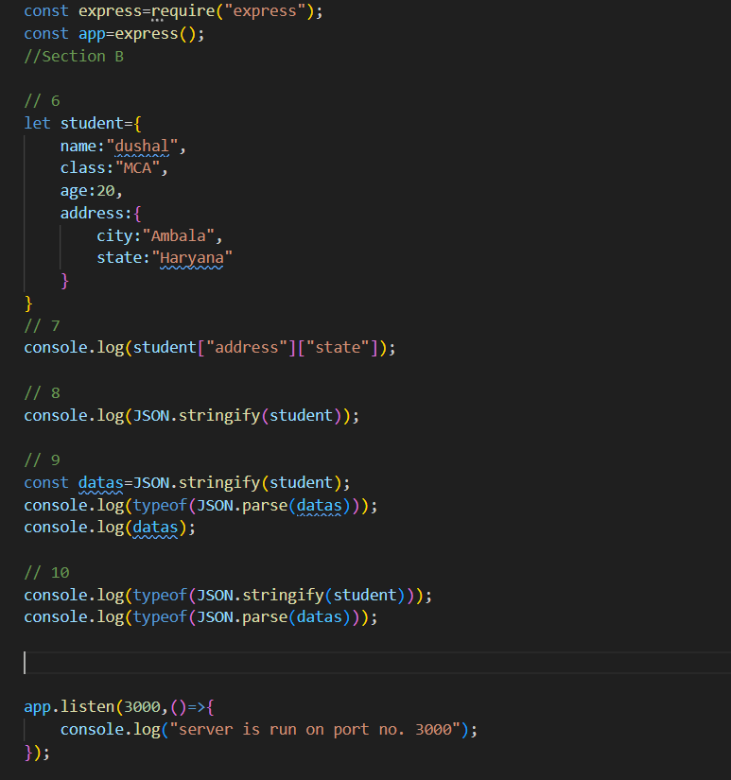
Section – C
11. Insert three documents into the “Your_Name” collection.
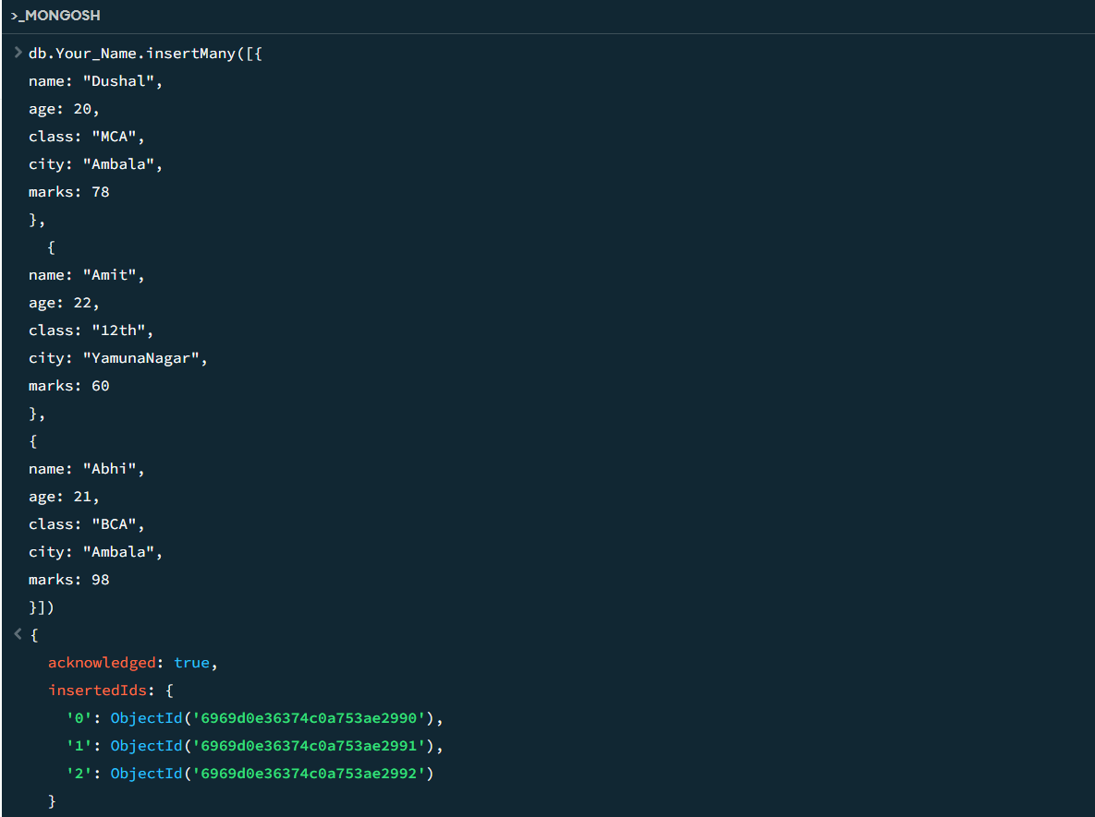
12. Find all students whose age is greater than 20.
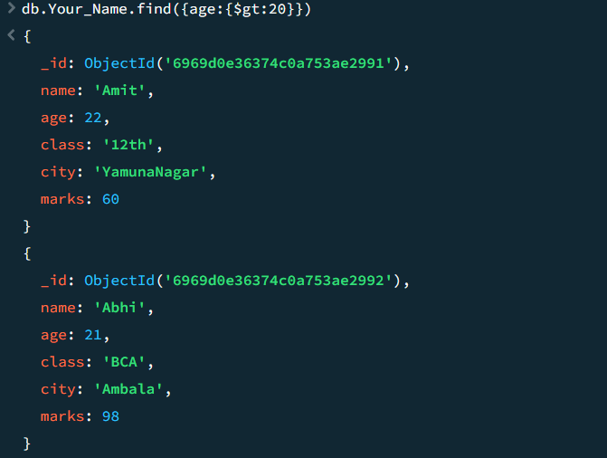 13. Find students whose city is either Ambala or Kurukshetra using $in.
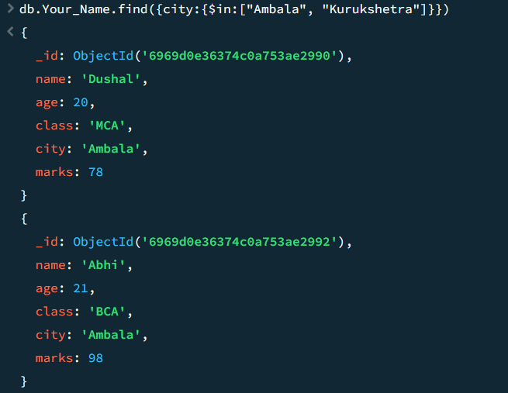
14. Find students whose marks are not equal to 50.
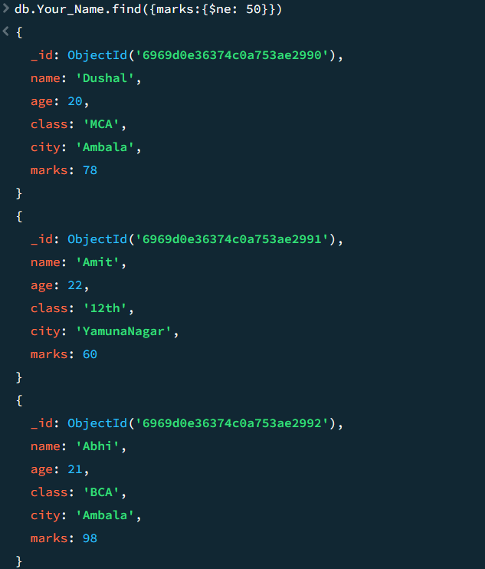
15. Fetch students whose age is between 18 and 25 using comparison operators.
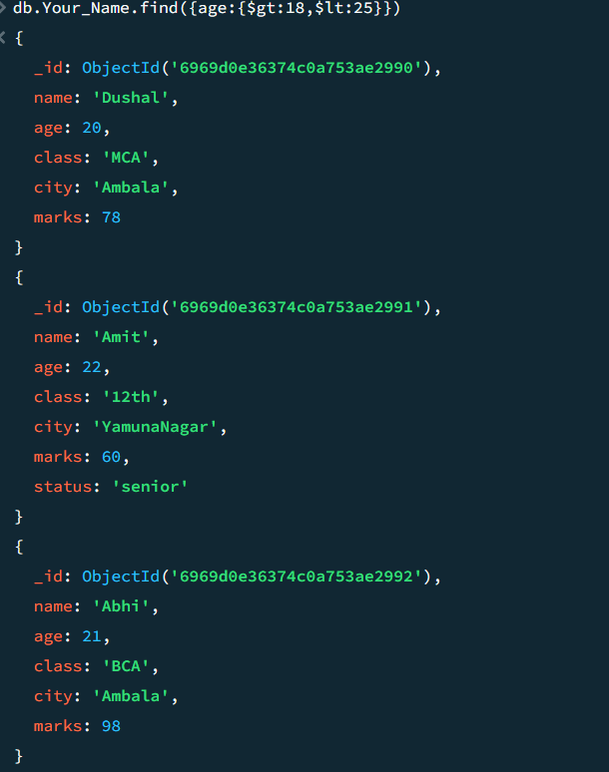
16. Use $or to find students who belong to Ambala OR have marks greater than 80.
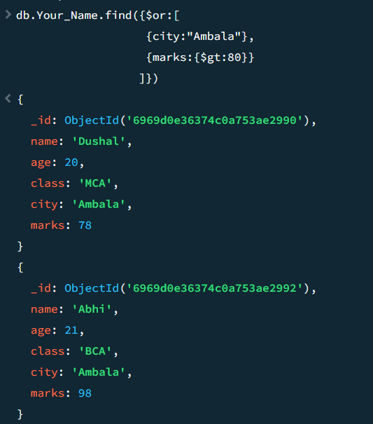
17. Use $and to find students who belong to Ambala AND age > 21. 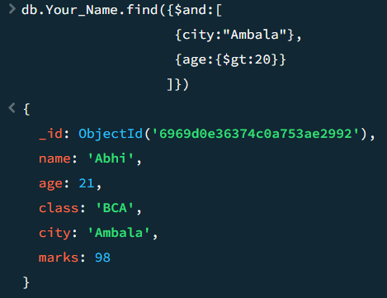
18. Write a query using $not to fetch students whose age is not greater than 20.
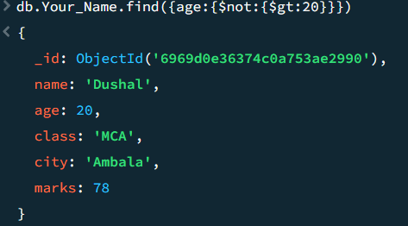
19. Use $nin to exclude students from cities Ambala and Delhi.
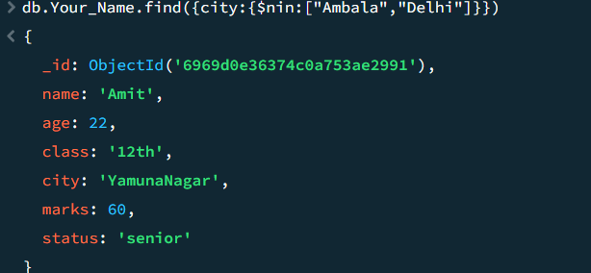
20. Use updateMany() to add a field status:"senior" for students with age > 22.
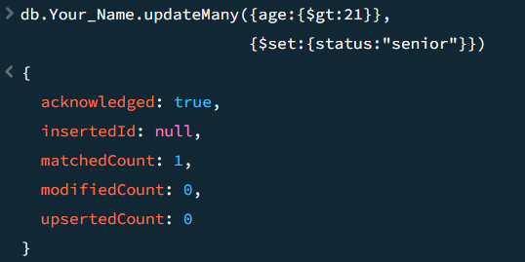

Section – D

21. Display only name and age of all students.
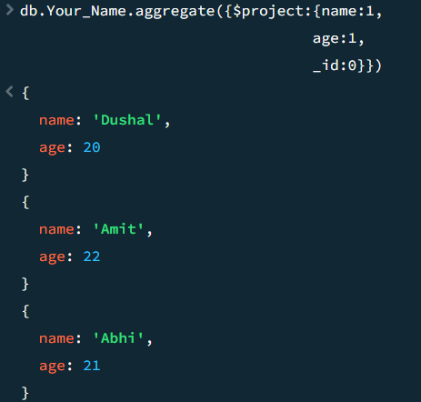

22. Display student data without _id field.
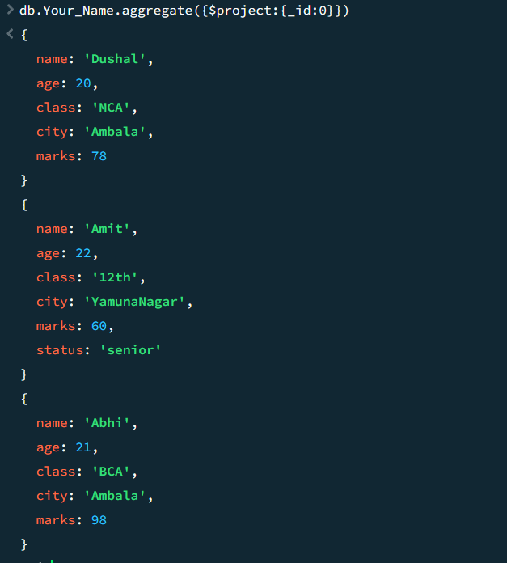

23. Show only name, class, and city for students of class "12th".
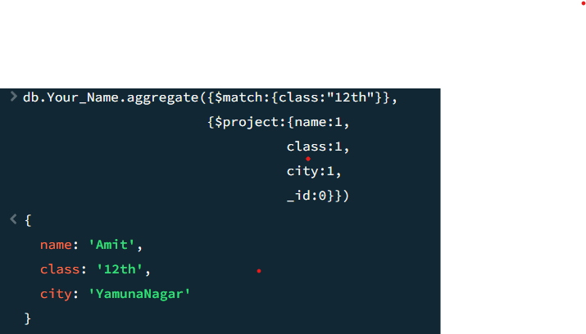
24. Combine filtering and projection to show name and marks of students with marks > 70.
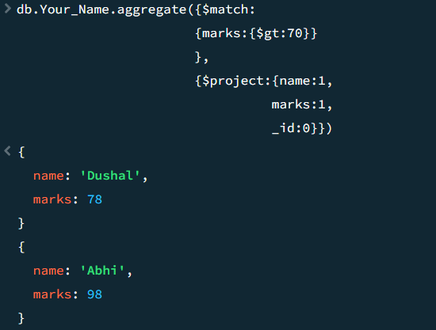
25. Write a query that hides age but shows all other fields.
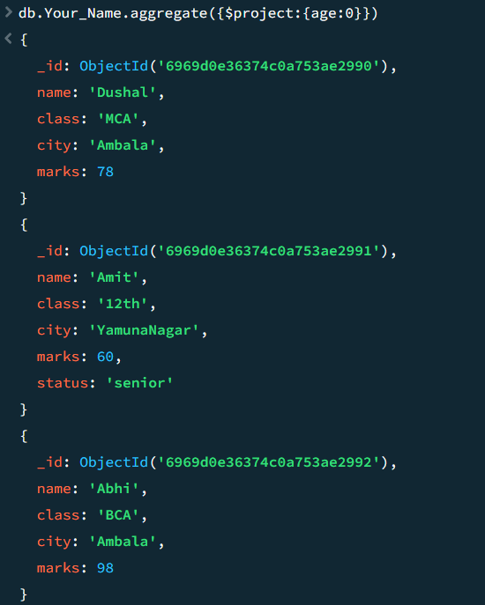
26. Explain with a query why inclusion and exclusion cannot be mixed in projection (except _id).
Ans. cannot mixed inclusion and exclusion statements in a single project, only id field will be excluded. 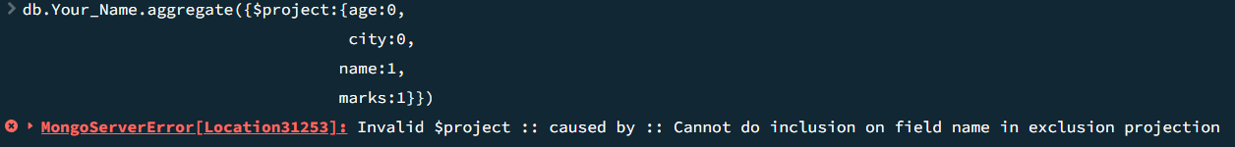
Section – E
27. Use $match to filter students whose age is greater than 20.
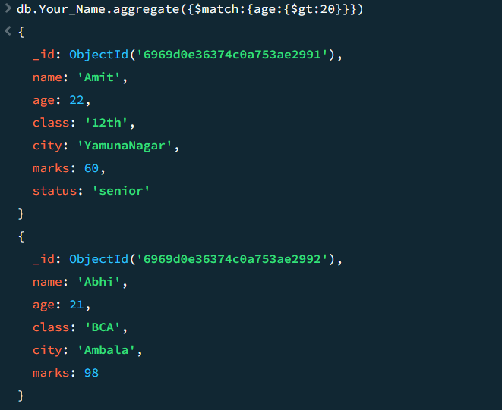
28. Use $group to count total students per city.
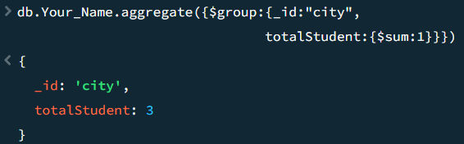
29. Calculate average marks per city using $group.
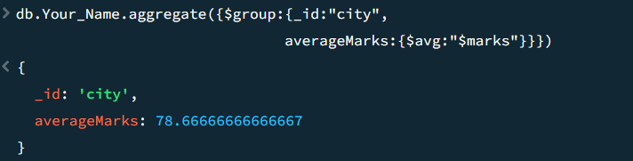
30. Use $project to display only name, marks, and a new field passed (passed = true if marks ≥ 40).
31. Sort students by marks in descending order using aggregation.
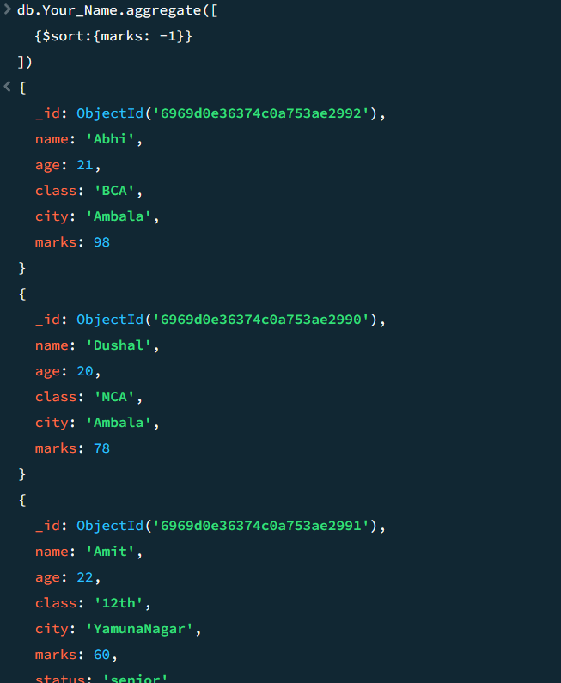
32. Display top 3 highest scoring students using $sort and $limit.
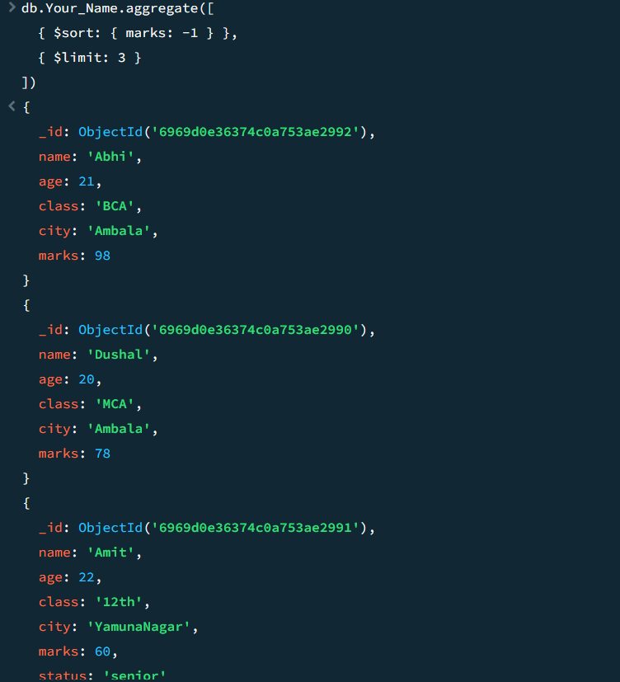
33. Skip the first 2 students and display the next 5 records.
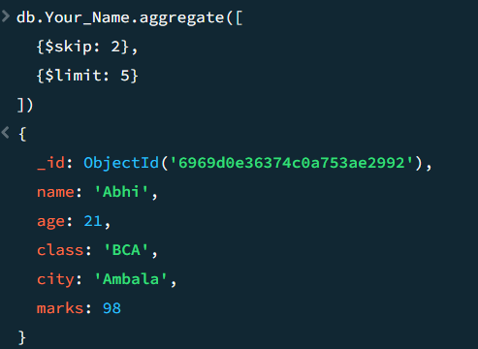
34. Given an array field subjects, use $unwind to break it into documents.
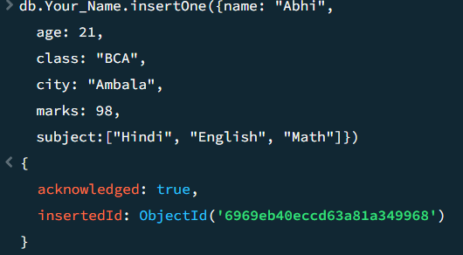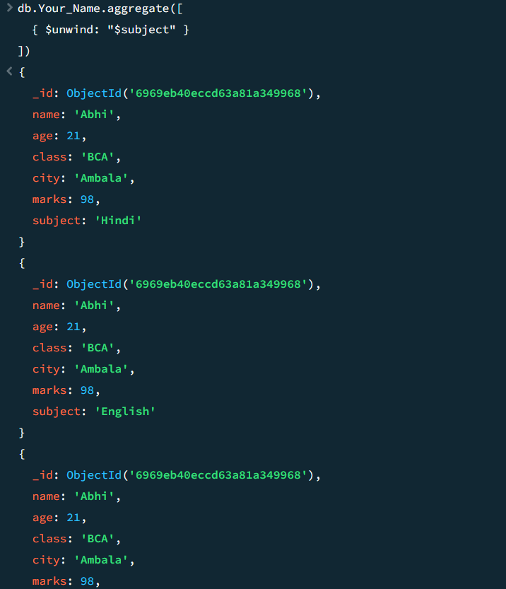

35. Perform a $lookup between “Your_Name” and users collection to fetch student details.
